

Litter Policy

We pick up litter wherever we can, whenever it is safe!

TRP will try and encourage our school community to always use correct bins. TRP believes that we have the right to learn, work and socialise in a clean, safe and happy environment - we are all responsible for our planet! Therefore we will:

- not drop litter inside the school building, school grounds or outside school
- use recycling bins for any waste wherever possible
- pick up litter from the school or outside area and put it in a bin
- work together to keep our school and environment litter free
- contribute to school litter clean up days.

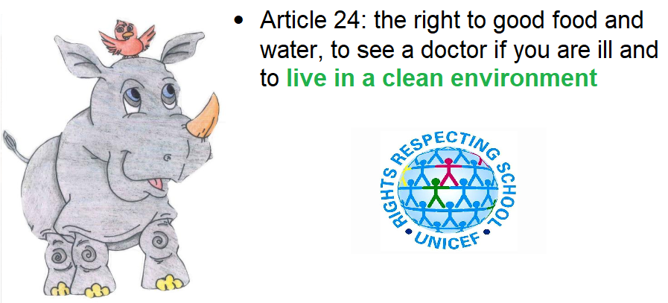
The Eco Committee will promote these messages but we need you to be responsible!

