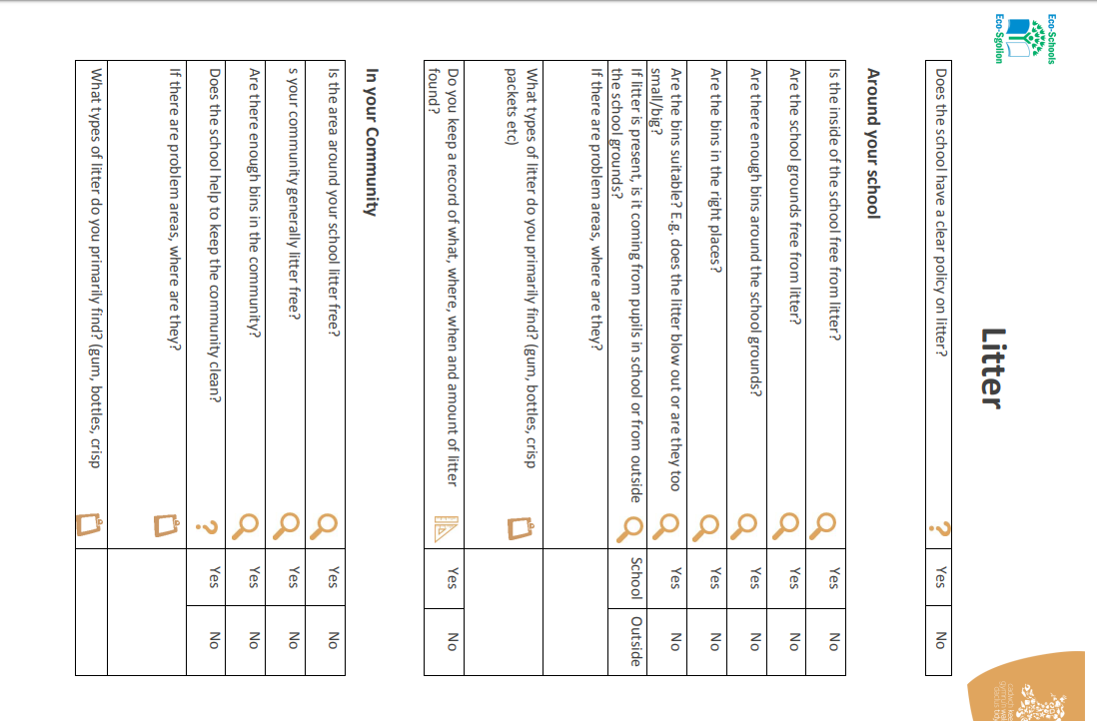
No
No
Some
Yes

Food Packets
Yes

Yes
Yes
Yes/ No
Yes
Yes
Outside
blows in through the fence
Food rappers and dropped fruit
We tweet our findings

Want fruit bins
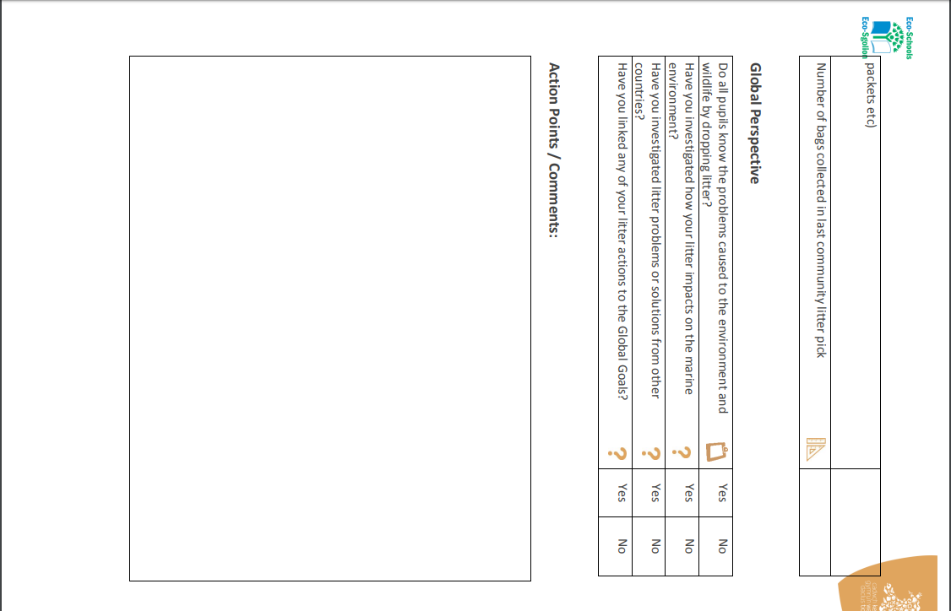
Following this review, The Eco committee of 2019/2020 would like to remind the local community about litter and waste! We will also continue to regularly pick litter in our school and complete a community pick during Green Day
Yes
Yes
Yes
No
1.5 bags

