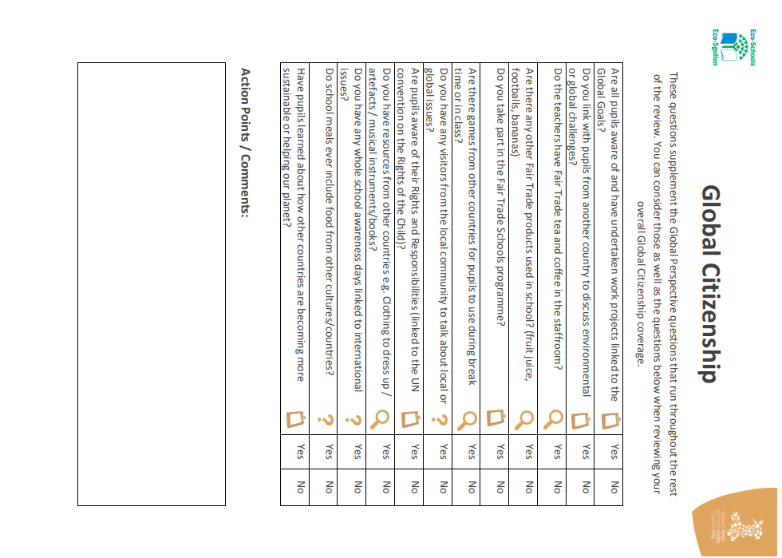
Following this review, The Eco committee of 2019/2020 would like to continue to work closely with our pupil voice groups, ‘International Friends’, ‘Rights Ambassadors’ and ‘Peace Mala’, who maintain global links.
Yes
Yes
Yes
Yes
Yes
Yes
Yes
Yes
Yes
Yes
Yes
Yes

